- Network Devices Assignment
- Simple Home Network Diagram
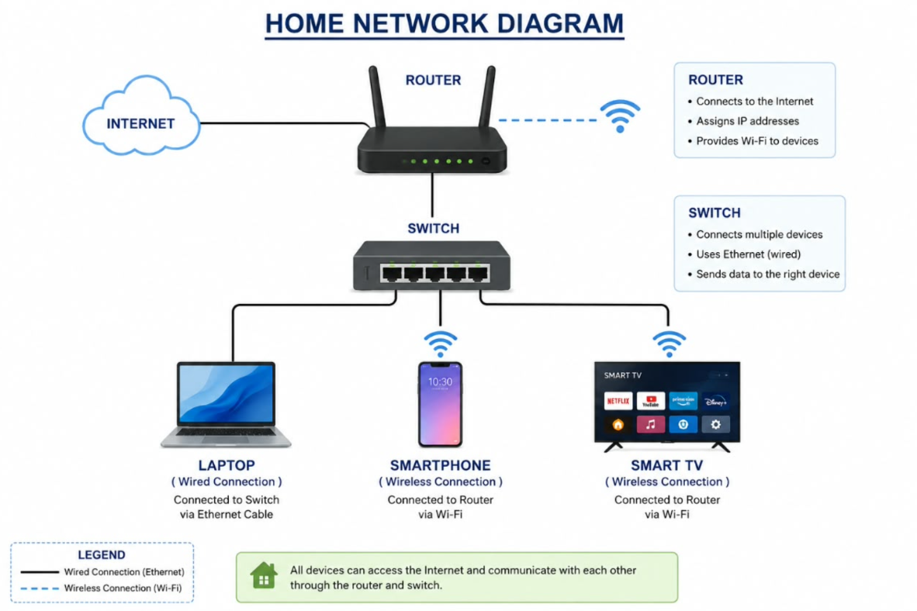
A home network connects different devices to the internet using a router, switch, WiFi, and Ethernet cables.
Explanation
- Router: Connects the home network to the internet.
- Smartphone: Connects to the router using WiFi.
- Smart TV: Connects to the router using WiFi and can be used for YouTube or Netflix.
- Switch: Connects multiple devices using Ethernet cables.
- Laptop: Can connect to the switch using an Ethernet cable.

2. Comparison of Network Devices
Network Device | Main Work | Real-World Use Case
Router | Connects different networks and provides internet access. | A home router connects phones, laptops and smart TVs to the internet for YouTube, browsing and online gaming.
Switch | Connects multiple wired devices in the same network. | A switch can connect several PCs in a computer lab for LAN gaming or file sharing.
Hub | Sends received data to all connected devices. | A hub can be used in a small practice network to learn how basic LAN communication works.
Access Point (AP) | Provides WiFi connectivity to devices. | An access point can provide WiFi in a college, office or home so users can browse the internet and stream videos.
Simple Difference
- Router → Connects networks and provides internet.
- Switch → Connects wired devices.
- Hub → Sends data to all connected ports.
- Access Point → Provides WiFi.
3. Scenario: Ordering Food on Zomato
Suppose I want to order food using the Zomato app on my smartphone.
First, my smartphone connects to my home WiFi. The access point in the WiFi router provides the wireless connection to my phone.
When I open Zomato and select a restaurant, my phone sends the request to the router. The router forwards the data towards the internet.
As the data travels through different networks, switches help forward the data between devices within those networks. The request finally reaches Zomato's servers.
Zomato processes my request and sends the restaurant information or order confirmation back through the internet.
The response reaches my home router, and its access point sends the data wirelessly to my smartphone.
Smartphone
↓
WiFi / Access Point
↓
Home Router
↓
Network Switches
↓
Internet
↓
Zomato Server
↓
Internet
↓
Home Router
↓
WiFi / Access Point
↓
Smartphone
Therefore, the router, switches and access point all help in transferring data when I use Zomato.
4. Connecting a Gaming PC Far From the WiFi Router
Situation
Suppose I have a WiFi router, but my gaming PC is far away from the router. The gaming PC only has an Ethernet port, so I cannot connect it directly to WiFi.
There are two possible solutions:
Option 1: Powerline Adapter
A powerline adapter uses the home's electrical wiring to transfer network data.
How it works:
- Connect the first powerline adapter to the router using an Ethernet cable.
- Plug the adapter into a power socket near the router.
- Plug the second powerline adapter into a power socket near the gaming PC.
- Connect the gaming PC to the second adapter using an Ethernet cable.
- The network data travels through the electrical wiring to the PC.
Internet
|
Router
|
Ethernet
|
Powerline Adapter
|
Home Electrical Wiring
|
Powerline Adapter
|
Ethernet Cable
|
Gaming PC
Advantage: It provides a wired connection without needing a very long Ethernet cable.
Option 2: WiFi Extender with Ethernet Port
A WiFi extender receives the WiFi signal from the main router and extends it to a distant area.
If the extender has an Ethernet port, I can connect my gaming PC to it using an Ethernet cable.
How it works:
- Place the WiFi extender between the router and the gaming PC.
- The extender receives the WiFi signal from the router.
- The extender repeats/extends the network connection.
- Connect the gaming PC to the extender using an Ethernet cable.
- The PC can now access the internet through the extender.
Internet
|
WiFi Router
|
WiFi
|
WiFi Extender
|
Ethernet Cable
|
Gaming PC
Advantage: It is easy to set up and does not require running a long Ethernet cable from the router to the PC.
Conclusion
Network devices are very important in our daily life. A router connects our home network to the internet, a switch connects wired devices, a hub sends data to all connected ports, and an access point provides WiFi.
We use these devices every day for activities such as YouTube streaming, online gaming, browsing websites, using Zomato, video calls and using social media.

